Toxic Test Sites

Design Documentation

Contents

High Level Design Overview 2

Main Objectives 2

Secondary Objectives 2

Design Motivations 2

DOOM (1993) 2

DOOM II 3

Key Elements 3

Expected Player Experience 3

Overview Map 3

Points of Interest 3

Aesthetic (Look and Feel) 3

Map 4

Doors and Secret Walls Map 5

Enemy Placement Map 6

Weapons, Ammo, and Health Placement Map 7

Pathway Maps 8

Golden Paths 8

Level Pacing 9

Challenges and Rewards 9

Balance Considerations 9

Testing Plan 9

# High Level Design Overview

## Main Objectives

The player must kill enemies to clear a path. This can be done using any of the four weapons that can be found in multiple places around the map.

The player must find keys and switches to open locked doors. Locked doors will display a different colored light matching the colour of the key required to open it. If the player tries to interact with a locked door, text will appear which states that the door requires a switch/ key to be unlocked.

Upon reaching the final room, the player must defeat an Eye Boss to access the end level switch. The boss room can be seen through windows at multiple points in the level.

## Secondary Objectives

Golden walls can be found around the map. These walls can be walked through to reveal useful items including weapons, ammo, health, and super ammo.

Players can open locked doors or go through golden wall to find weapon pickups earlier on which can give them an advantage against the enemies.

If the player collects four super ammo charges, they can unleash a super attack which deals massive area-of-effect damage to all enemies in its radius.

## Design Motivations

### DOOM (1993)

The level features some circular paths similar to that in DOOM. Circular paths bring the player back to the main pathway without them needing to backtrack.

Similar to in DOOM, dead Doomguys can be found around the level. They are used to signify danger to the enemy by being placed in dangerous areas like in slime and near enemy triggers.

There are also some close-quarters, maze-like areas in the level in order to recreate some of the claustrophobic and horror elements that DOOM had.

The level encourages the player to ‘dance’ around enemies when engaging in combat. The “DOOM dance” is a very integral part of DOOM’s gameplay as players who can master the game should be able to flawlessly dodge and weave through enemy projectiles, while simultaneously dealing out damage to the enemies.

### DOOM II

Similar to DOOM II’s level 13: Downtown (in which the player must navigate a city environment), the final area in the level is outside and reveals many eyes outside the map which are monitoring the player.

## Key Elements

## Expected Player Experience

It is a standalone level meaning that the beginning of the level starts off easy and introduces the player to certain mechanics and enemies. In addition, players will face challenges tailored for weapons that they pick up. (i.e., a bunch of zombies will spawn in a tightly packed group after the player picks up a grenade launcher. This allows the player to experience the area-of-effect damage the grenade launcher deals.)

The level is aimed at players who are somewhat experienced with first person shooter games as the later sections of the level becomes quite difficult. This is due to factors like: more enemies, more difficult enemies, less ammo pickups, less health pickups etc.

# Overview Map

## Points of Interest

* At multiple points in the level, the boss area can be seen through windows.
* A slime pit with a trigun and super ammo pickup in the middle, the player can see this through multiple windows, and can get inside the slime pit room via a golden wall.
* The first grenade launcher pickup is visible through a window (with a dead Doomguy outside the window in the slime). A pair of double doors can be seen behind the grenade launcher, indicating to the player that they should look out for a pair of double doors later in the level.
* A maze containing a keycard to open a door the next area. The player is able to see the key at the entrance to the maze through a window.
* A giant eye in the sky in addition to buildings containing eyes overlooking the player in the outside section of the level.

## Aesthetic (Look and Feel)

* The game looks very similar to DOOM (1993), as it is a first person shooter with 2D sprites (e.g. The weapons that are being held by the player are 2D, enemies and pickups are 2D and rotate towards the player camera).
* As the name of the level suggests, there are lots of slime blocks throughout the map.

# Map

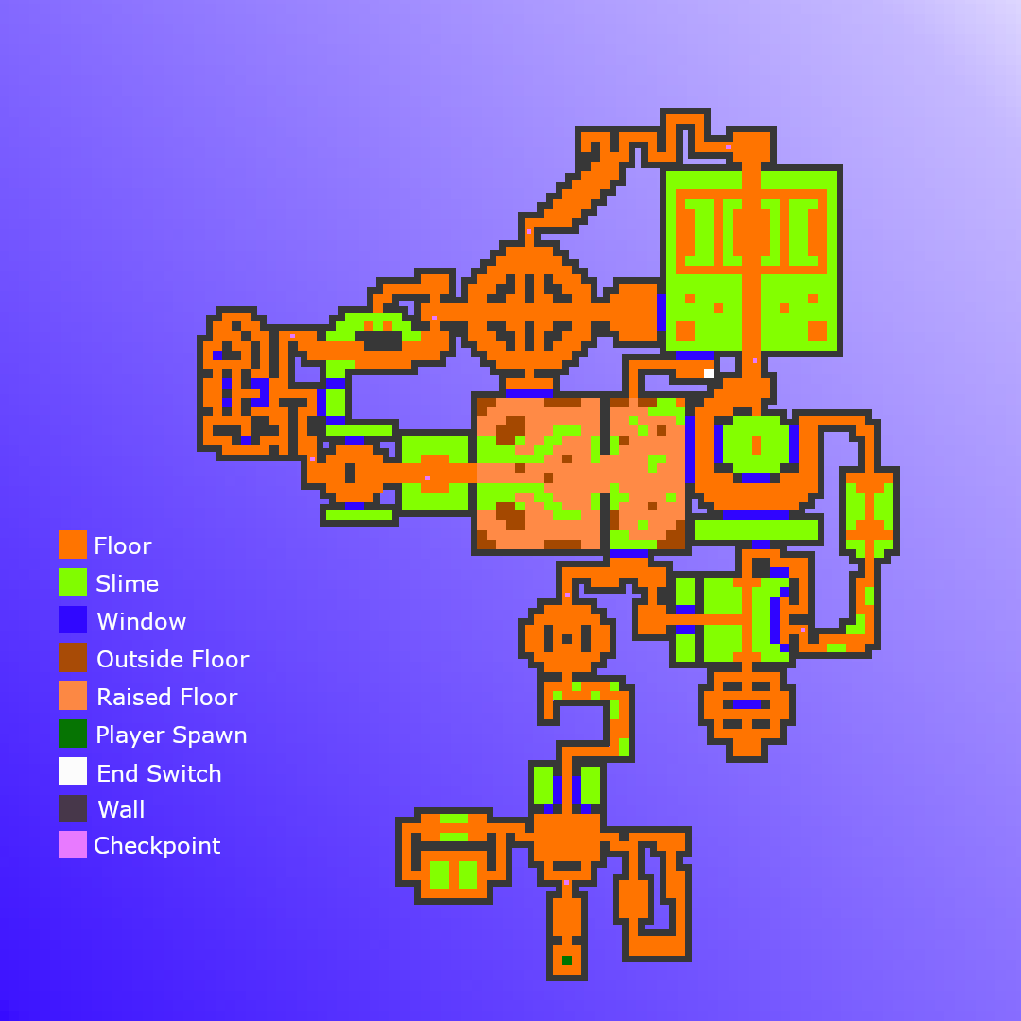

# Doors and Secret Walls Map

Red and white sections which span across the whole corridor are doors, whereas red and white squares are switches and keys, respectively. The lines between doors and switches/ keys are the links between them (i.e., a line between a key and a door means that key opens that door).

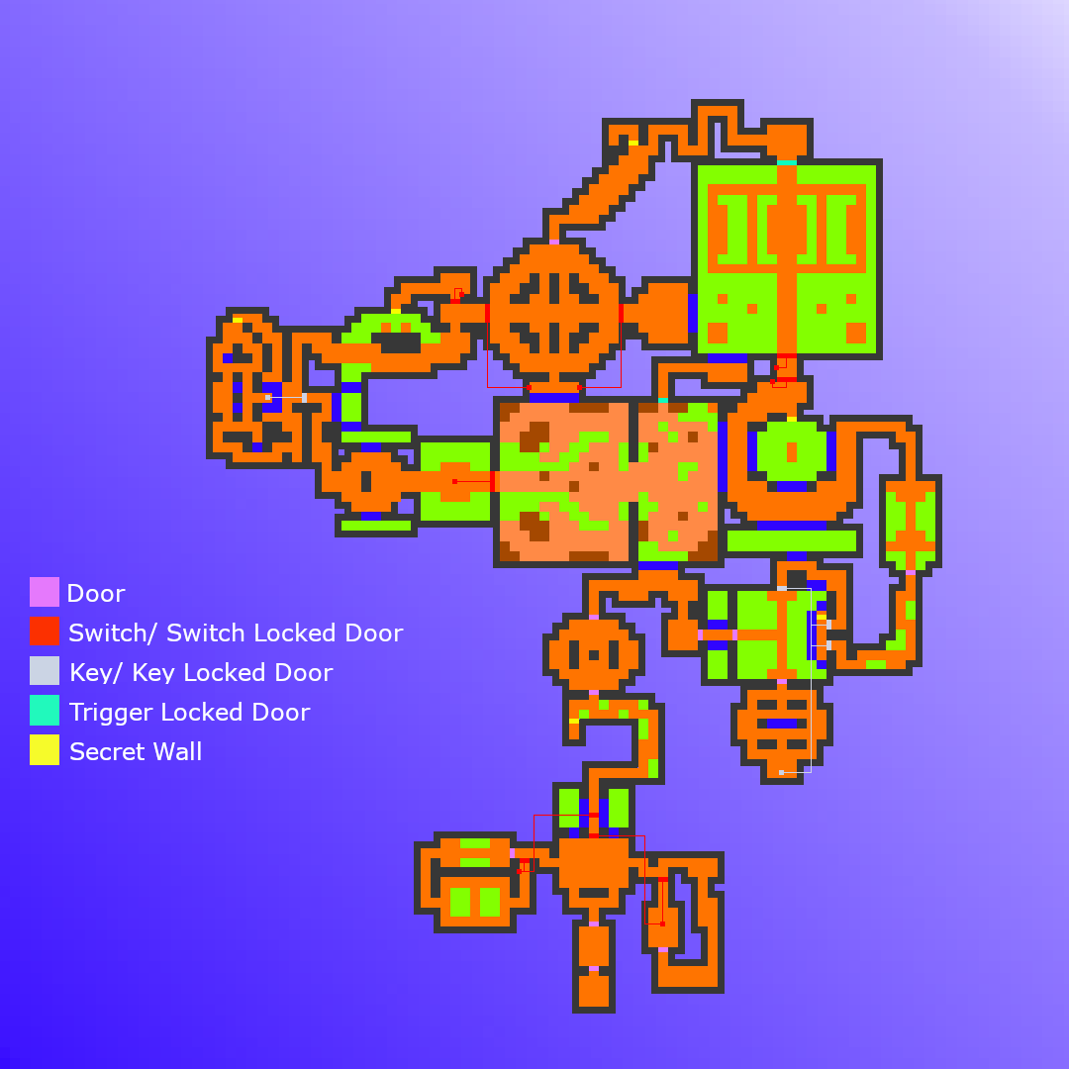

# Enemy Placement Map

The flat (non-jagged) side of the triangles represent the back of the enemy.

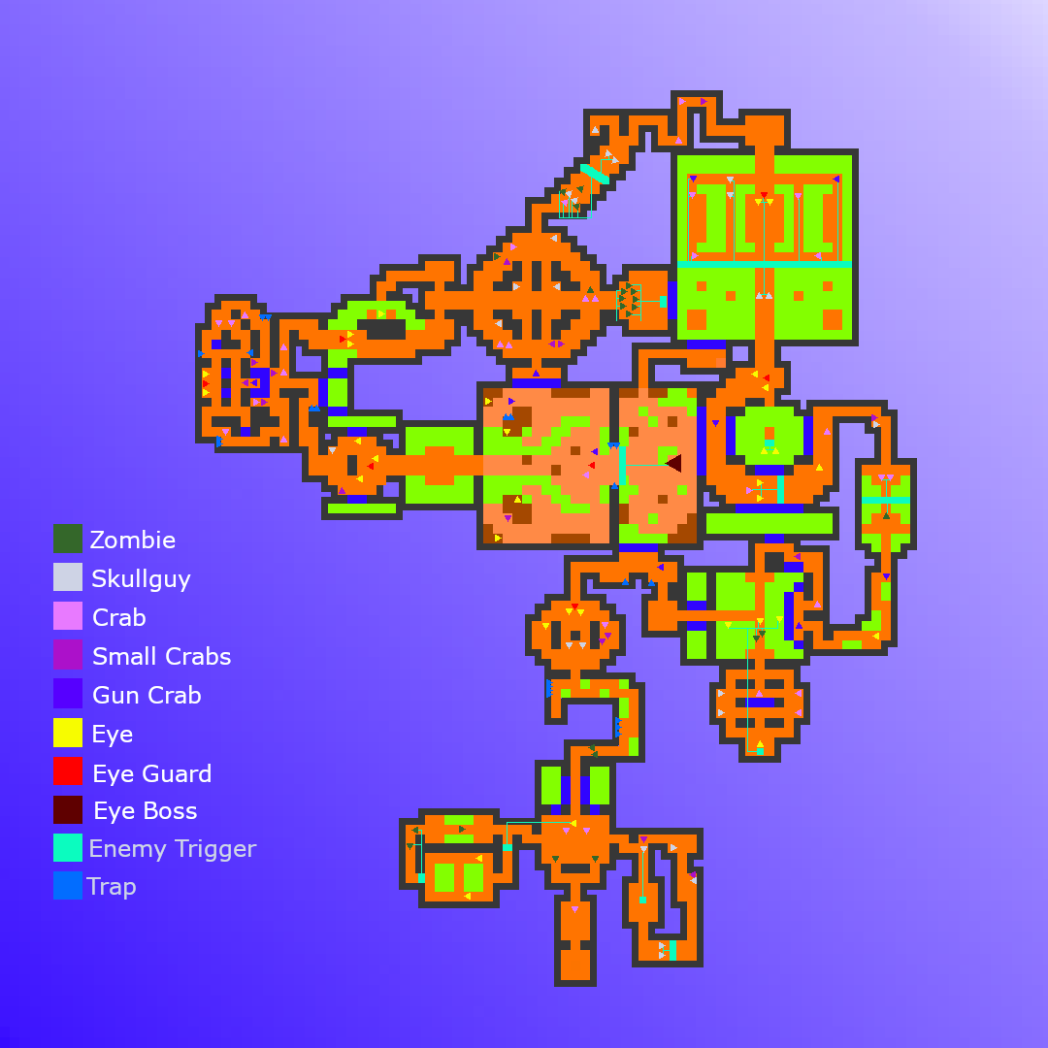

# Weapons, Ammo, and Health Placement Map

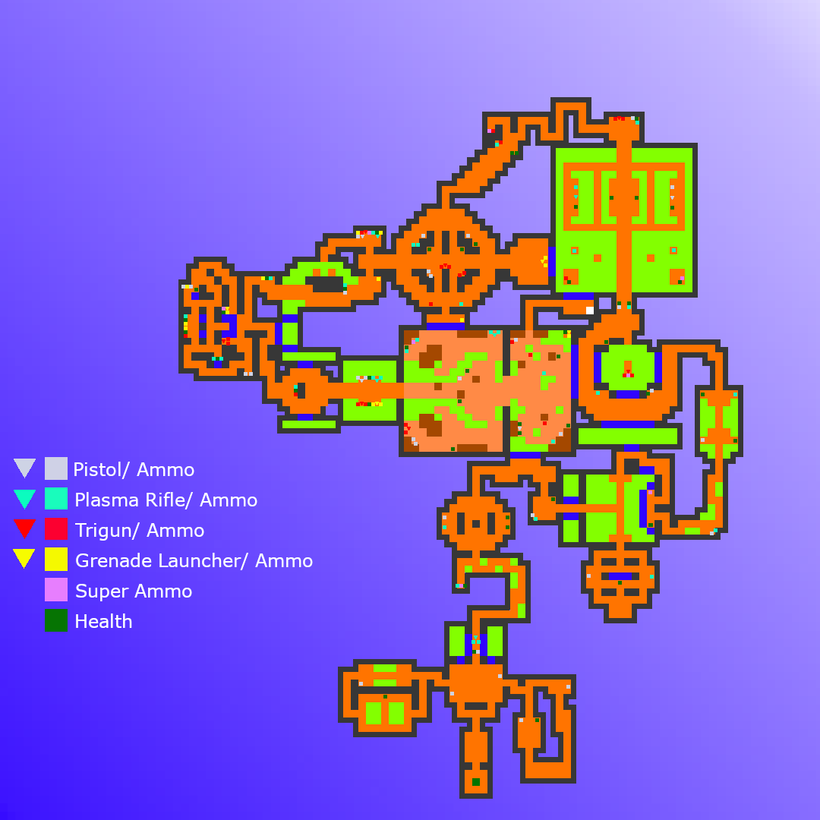

# Pathway Maps

## Golden Paths

The numbers represent the order in which the player must navigate the path.

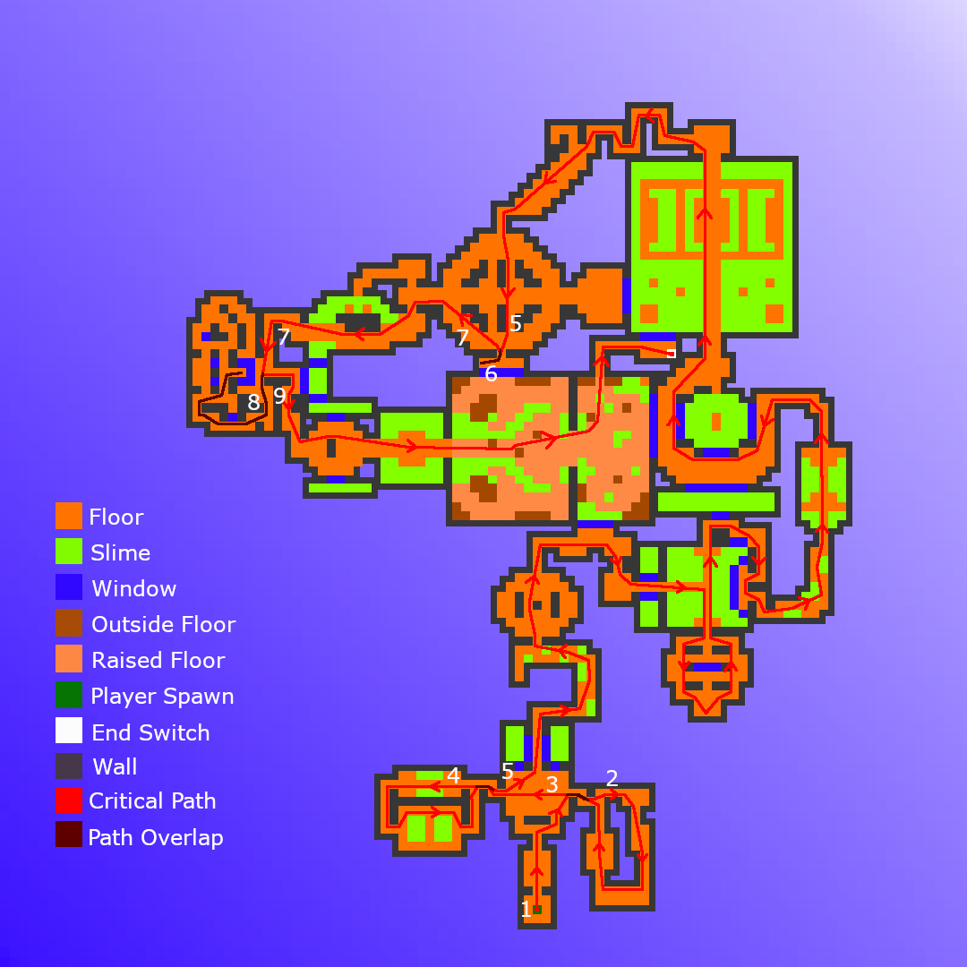

# Level Pacing

## Challenges and Rewards

* By the first locked door that the player will encounter, a plasma rifle, ammo, and health pickups are visible behind the locked doors via a window. This shows the player that they should revisit this area later on after interacting with some switches in order to reach the pickups.
* Super ammo, weapons pickups, ammo, and health can be found behind golden walls. Most secret walls are either difficult to reach or have small challenge on the other side.
  + For example, the first golden wall is located behind a slime block with many traps on the adjacent wall, making it hard to see and a challenge to reach.
  + The first trigun pickup and super ammo can be found in a slime pit behind a golden wall, upon picking up the trigun, two eyes will spawn in front of the player at close enough distance to kill with the trigun.

# Balance Considerations

## Testing Plan

Other Advanced Level Design students will playtest my level and will fill out questionnaire form. They can also leave notes on aspects of the level that they like/ dislike.

After receiving the questionnaire forms, I will then be able to make changes to my level based on any relevant feedback.

Due to the large size of my level, I may not be able to have players playtest the whole level as it may take too long. To tackle this problem, I can move the player’s spawn location to different points in the level so that all areas of my level can receive feedback.